DATE: 05.07.2019
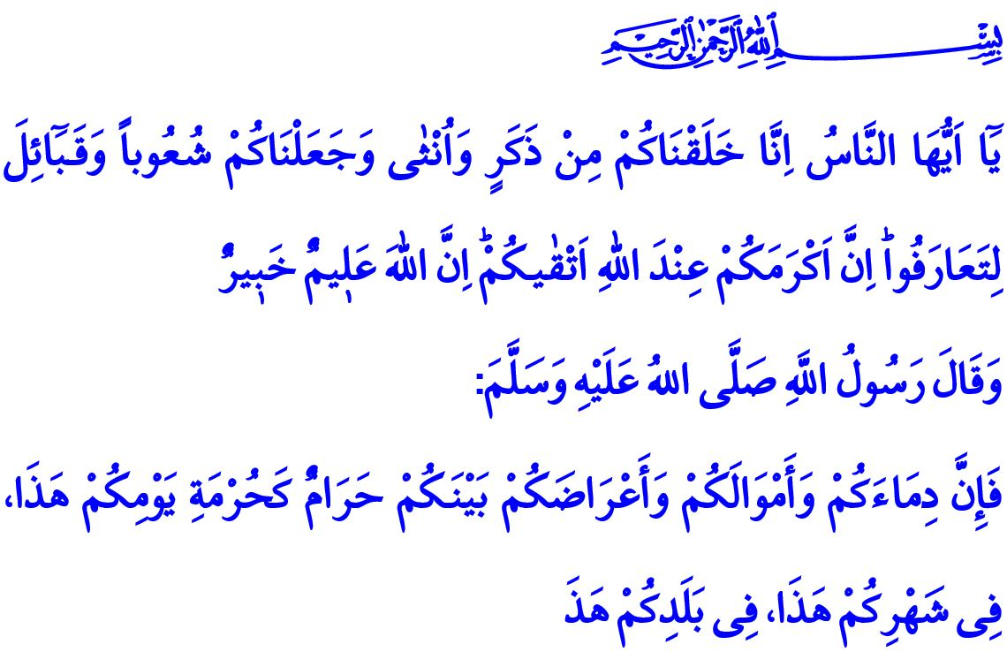PRESERVATION OF FAMILY ENVIRONMENT: A RIGHTEOUS AND PEACEFUL FUTURE
Honorable Muslims!
The Almighty Allah (swt) states in the verse I have quoted, "O people! Indeed, We have created you from a male and a female, and made you into tribes and nations so that you may get to know one another. Surely, the most noble of you in the sight of Allah is the most righteous among you. Allah is truly All-Knowing, All-Aware."
The Prophet Muhammad (saw) says in the hadith I have quoted, "O people! Your blood, property, and honor are sacred to one another like the sanctity of this day of Eid al-Adha in this month of Dhu al-Hijjah in this city of Makkah."
Dear Muslims!
We are born, when the Almighty Allah (swt) appreciates, to the mother and father that are predestined by Him, and again with the gender designated by Him. The creation of human beings in two genders as male and female is one of the proofs of Allah’s (swt) existence and power. In this sense, it is Allah (swt) Who has bestowed different abilities and superiorities upon to man and woman, made them spouses to each other, and had them have children since Adam (as) and Hawwa (ra).
The creation of human beings as male and female is the predestination of the Almighty Allah (swt) and a condition reqired by the laws of Allah, which bears many wisdoms. What falls upon us as His servants is to respect His disposition, display respect to both genders, and establish and sustain justice and compassion between them.
Honorable Muslims!
The Exalted Allah (swt) wants us to live a life in accordance with the wisdom underlying our creation, and the honor and dignity of being human. He wants us to get married, have a family, and bring up strong and faithful generations. Protecting our children and safeguarding our future are the duties of all of us as His believing servants. The security of our children is as much valuable and inviolable as the security of our lives and properties. Our chastity, dignity, and efforts to live by halal means are sacred.
Dear Believers!
The most valuable institution that help protect the chastity, respectability, and rights of both man and woman is family. Family life establishes the bonds of trust and peace between us. All kinds of opinions and behaviors that ignore family and destroy family structure, in fact, target social bonds.
In order for a society to look at its future with hope, the first thing to is to encourage the young people of marriage age to get married and set up legitimate relations. For family is the oldest, the most deep-rooted unit, and the strongest tower for humankind to continue living in a proper way, from past to present.
Dear Muslims!
Marriage is the most blessed contract concluded pursuant to the commandment of Allah (swt) with reference to the Prophet Muhammad (saw). Marriage means both happiness and responsibility for man and woman. Extramarital relationships and "unrestricted approaches" diguised under the name of "sexual freedom" are far from respecting the rights and integrity of men and women. Living together without a legal and recognized marriage is prohibited by Allah (swt). Nothing good results from a wrong path full of haram. For haram always causes misperceptions and is destructive; it harms people and damages society.
Honorable Muslims!
Allah the Exalted (swt) has predestined our gender just like our race, skin color, and lifetime. Trying to change the codes of human nature and the innate characteristics of genders are against the laws of Allah (swt). The attempts to interrupt genders and the efforts to promote genderlessness would destroy not only individuals but also the entire generation eventually. Disregarding the divine will by presenting the choice of gender as if it were an individual freedom and choice means to step out of line and deviate from servitude to Allah (swt). All beliefs have rejected and cursed such understandings throughout the history.
Honorable Believers!
Nations survive thanks to their religious and moral values. When these values are weakened, the society starts to be dissolve, and our future will be endangered. The Almighty Allah (swt) informs us of the destruction of many communities throughout the history because they ignored the revelation and went through moral corruption and perversion. According to the Holy Qur'an, the Prophet Lot addressed his people of corrupted human nature, “We had sent Lot as a prophet. He scolded the men of his people, "Do you commit a shameful deed that no man has ever done before? You lust after men instead of women! You are certainly transgressors!"
Dear Muslims!
Let us draw a lesson from the tribes that were destroyed because of their depravity and stepping out of line. Let us strive to live a decent life in compliance with our nature. Let us protect the honor and dignity of humanity by considering them as our dearest and most precious values just as we protect our lives. Let us stay away from extremisms and improper practices that may harm the honor of man and woman. Let us value and show due care to our daughters and sons as they deserve. Let us remember that we are all responsible of bringing up proper generations, which is only possible through educating our children and young people against perverted understandings, raising their awareness, and protecting them.

Hujurat, 49/13.
Bukhari, 'Ilm, 9; Muslim, Qasamah, 30.
A’raf, 7/80, 81. General Directorate of Religious Services

